***THEORY***

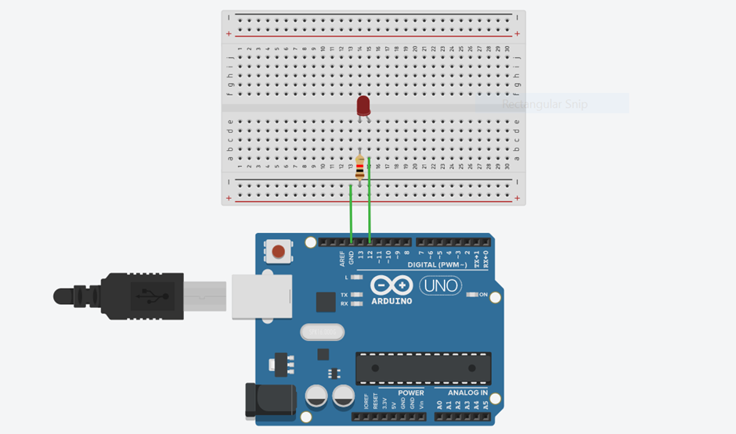

***Concept Used:-***

|  |
| --- |
|  |
|  | * ***An arduino is a very useful microcontroller. Therefore, it can be programmed via the Arduino language Processing to turn the*** |
|  | * ***LED on for a given interval of time and turn it off for a certain period of time. We can use it over and over again.*** |
|  | * ***To control the amount of time the LED will be on and the amount of time it will be off can easily be decided by our software code*** |
|  | ***using the delay.*** |

***Learning and observations:-***

* ***The coding is done using computer with the help of it the instructions are provided to the Arduino Uno board .***
* ***Coding done on Arduino software is C++ .***
* ***Arduino is a single-board microcontroller meant to make the application more accessible which are interactive objects and its surroundings.This micro controller gives the valid instruction to the elements fitted on the breadboard according to coding done on software.***

***PROBLEMS & TROUBLESHOOTING:-***

* ***To select the right port and type of arduino.***
* ***To check the loose connections .***
* ***To check the connections according to the codes.***
* ***To check the continuity of the circuit .***
* ***To check the flow of current in the circuit..***

***PRECAUTIONS:-***

* ***These electrical components are delicate to handle.***
* ***Also the safety comes first when we are dealing with electric work.***
* ***Firstly I studied the experiment and learnt about the necessary knowledge required to perform the experiment.***

***Learning Outcomes:-***

* ***LED is a diode having two ends P-type and N-type and glows with a very less amount of current. Arduino is used to program the microprocessor in certain way given.***